Snow Plowing Responsibilities in Little Rocky Run
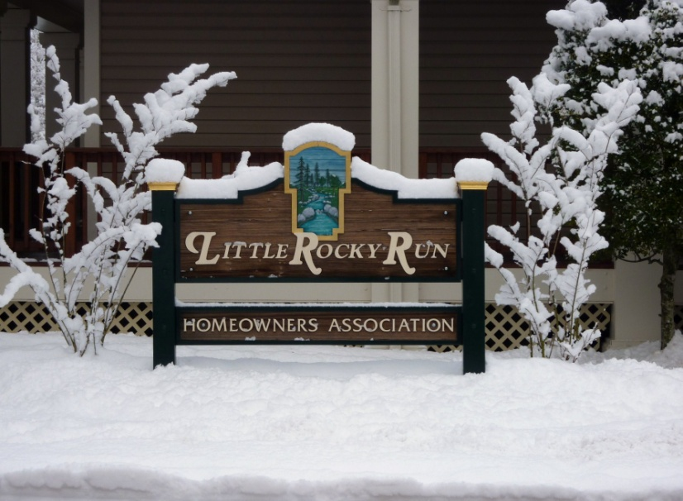

The responsibility for snow plowing in LRR is shared by the Virginia Department of Transportation (VDOT) and the Homeowners Association. In addition, there are areas that are the responsibility of homeowners.
Areas of Responsibility for the HOA
Town home courts - drive lane only, with the exception of Little Rocky Run Circle, Sunset Ridge Road, Sequoia Lea Drive and Braddock Creek Road. No parking spaces will be plowed on town home courts.
Recreation center parking lots.
Areas of Responsibility for the Virginia Department of Transportation (VDOT)
703-383-8368 or 1-800-FOR-ROAD (1-800-367-7623) http://www.511virginia.org/mobile/?menu_id=conditions
http://www.virginiadot.org/about/resources/nova_snow/snow_fact_sheet.pdf
For current road conditions in Fairfax county and surrounding areas, please click here - 511 Virginia.
Motorists can call VDOT's new Customer Service Center at 1-800-FOR-ROAD (1-800-367-7623) if they witness unsafe road conditions or if they have questions about VDOT activities. Please contact 511 for traffic and road conditions.
Little Rocky Run is not permitted by the state of Virginia to operate plows on VDOT maintained roadways. VDOT will impose a fine on the HOA for plowing on these streets or roadways as an unauthorized contractor.
How Residents Can Help
Residents can help expedite the snow-removal process by staying home if possible during severe weather. Residents should remove their cars from the roadway when they can. This will help crews clear the snow from area roads as efficiently as possible. Last winter, as road conditions deteriorated throughout the winter storms, crashes and abandoned or disabled vehicles became significant impediment to clearing the roads of snow and ice.
The following streets in Little Rocky Run are maintained by VDOT.
The streets are listed here in alphabetical order. ** indicates a street located in a town home area of the neighborhood.
Battle Rock Drive  Battlewood Court  Bluestone Court  Bluestone Place  Bluffdale Court  Braddock Creek Road**  Bridgeland Lane  Clear Springs Court  Clear Springs Lane  Deepwood Farms Drive  Foggy Hills Court  Foggy Hills Way  Forest Run Drive  Laurel Rock Drive  Laurel Run Court  Little Rocky Run Circle**  Maple Run Court  Marblestone Court  Marblestone Drive  Melstone Court  Melstone Drive  Moss Glen Court  Moss Glen Road  Mountain Springs Court  Mountain Springs Lane  Noble Rock Court  Noble Rock Drive  Noble Rock Lane | Oak Stone Court  Otter Run Court  Otter Run Road  Rock Brook Court  Rock Brook Drive  Rock Crystal Drive  Rock Fall Court  Rock Flint Court  Rock Hollow Lane  Rock Lawn Drive  Rock Still Court  Rockland Court  Rockland Drive  Sandstone Court  Sandstone Way  Sequoia Lea Drive**  Shalestone Court  Shalestone Drive  South Springs Circle  South Springs Court  South Springs Drive  Spring Pond Road  Springhouse Circle  Springhouse Court  Springstone Court  Springstone Drive  Springstone Place | Stone Shadow Court  Stonebrook Court  Stonebrook Drive  Stonedale Court  Stonedale Lane  Stonefield Drive  Stonefield Lane  Stonehaven Court  Stonehunt Court  Stonehunt Place  Stonehunt Way  Sunset Ridge Road**  Union Springs Court  Union Springs Lane  Union Village Circle  Union Village Court  Union Village Drive  Warm Spring Court  Whetstone Manor Court  White Stone Court  Wilder Court  Woodland Run Court  Woodland Run Drive
Single Family Homes
Mailboxes - clear a path for the mail carrier. Single Family Homeowners are reminded to clear the full approach and exit to private mailboxes. Due to safety factors, mail carriers ARE NOT PERMITTED to back up or exit their vehicles at the mailbox. If the mailbox area is not properly cleared, mail cannot be delivered safely. Your cooperation is sincerely appreciated. If you have any questions, contact your post office: 703-830-7690
Sidewalks - Neither VDOT, the county nor LRR HOA clears snow and ice from public walkways (sidewalks and trails). While not legally obligated by the county, residents and businesses are asked to help keep sidewalks safe, when possible, by clearing snow off the sidewalks in front of their property so that all pedestrians, especially school children, those with disabilities and the elderly, may walk securely.
Townhomes
Parking spaces - the Association does not clear individual parking spaces
Sidewalks - Neither VDOT, the county, nor the HOA clears snow and ice from public walkways (sidewalks and trails).
While not legally obligated, residents and businesses are asked to help keep sidewalks safe, when possible, by clearing snow off the sidewalks in front of their property so that all pedestrians, especially school children, those with disabilities and the elderly, may walk securely
Asphalt Trails
Little Rocky Run has many miles of asphalt trails throughout the community. Unfortunately, the cost to remove snow from these trails is prohibitive, therefore, the Association will not remove snow from asphalt trails.
Please read the resolution below passed by the Board of Trustees regarding the use of the Association's asphalt trails:
RESOLUTION
WHEREAS, the Little Rocky Run Homeowners Association (“LRRHOA”) owns and maintains numerous walking trails on common property for recreational use; and,
WHEREAS, LRRHOA performs maintenance and repair of these trails but does not remove snow or ice from the trails or provide any form of security with respect to the common property, including with respect to the walking trails; and,
WHEREAS, the trails are intended, consequently, for seasonal use only and may become hazardous if used out of season or for other purposes.
BE IT THEREFORE RESOLVED, that the Little Rock Run walking trails shall be used for recreational purposes only and, except as otherwise expressly authorized by the Board of Trustees, the trails are not approved for any other use; and Trail users shall be informed from time to time through the LRRHOA’s official means of communication of the trails limited, approved use.
Adopted by the Little Rocky Run Homeowners Association Board of Trustees this 12th day of May, 2004.
Pipestems
What is a Pipestem?
The single-family neighborhoods of Little Rocky Run have numerous private driveways which are called Pipestems.
Pipestems are not found in all neighborhoods and some residents who live near a Pipestem may not be aware of what a private driveway or a Pipestem really is and what guidelines govern them. These driveways are private property and are collectively owned by the homeowners who share these driveways. The residents themselves are responsible for the upkeep of the Pipestem including paving and snow removal, just as other homeowners are responsible for their individual driveways. The Pipestems are not to be parked on either by the Pipestem owners or any other residents in the neighborhood except for delivery and/or emergency vehicles.
Pipestems are to be used exclusively for the purpose of ingress and egress to the affected homeowners properties. All of the residents who live on Pipestems ask that other residents respect their private property and refrain from parking and using the Pipestem as a public roadway and walkway.
How To Get Snowplowing for the Pipestem
Homeowners with homes located on common driveways called "Pipestems" are responsible for the removal of snow and ice on those Pipestems.
Every home on the common driveway must agree to all costs associated with hiring a service to remove snow and ice. The HOA is not responsible for ANY common driveway snowplowing agreement. Any such contract is strictly between the homeowners and the contractor of their choice. Homeowners who reside on common driveway who wish to sign up for contracted snow removal services should do the following:
 First, obtain copies of a Common Driveway Snowplowing Agreement from the contractor you wish to hire.
 Distribute agreements to each home on the Pipestem
 Collect the signed agreement and a check from each home to cover the cost of the contract. Checks should be made out to the contractor not the HOA.
Plowing services typically include breaking a navigable pathway down each common driveway, but does not usually include plowing each individual driveway. If your contractor of choice offers driveway plowing separately each homeowner should be made aware of any additional costs.
Motorist Resources
VDOT has a variety of information sources for road condition updates. The 511 traveler-information service gives drivers the most up-to-date data available about weather, construction and accidents that may affect travel. Updates can be received by calling 511 from any landline or wireless phone or by going online to http://www.511virginia.org/ to view traffic cameras, the road condition map and the road condition table-report. Individuals can sign up for e-mail alerts that include weather and incident reporting on the 511 Web site.
For overall winter weather information, VDOT's Web site includes frequently asked questions, driving tips and tools for motorists to learn more about VDOT's winter preparedness at http://www.virginiadot.org/travel/snow.asp.
Drivers can also view videos detailing how VDOT prepares for winter weather and address snow and ice on You Tube. Snow videos are posted at http://www.youtube.com/user/vdotweb#grid/user/84A0942814F2FECC
For more information about Virginia's efforts to prepare for winter weather and other emergencies, visit http://www.readyvirginia.gov/. The National Weather Service, Virginia Department of Emergency Management, Virginia Department of Social Services and other state agencies have created the "Ready Virginia" resource to provide residents and visitors with a one-stop shop for emergency preparedness tips and information.
Driving Tips:
- Check road conditions before they leave home by calling 511 or logging in to 511Virginia.org.
- Slow down and allow for extra time to reach your destination.
- Be aware of potentially icy areas such as shady spots and bridges.
- Keep a safe distance of at least five seconds behind other vehicles and trucks that are plowing the road.
- Do not pass a snowplow or spreader unless it is absolutely necessary.
- Motorists waiting in traffic should:
  - Stay in their cars
  - Conserve their fuel by not running the engine continuously.
  - VDOT recommends running the car engine for heat for 10 minutes and then turning off the engine for 20 minutes. Make sure snow is not blocking the exhaust pipe to avoid carbon monoxide poisoning.
  - Understand that it will take time for emergency crews to reach you.
- Motorists should only call #77 and 911 for emergencies. Road condition information is available by calling 511 or by visiting http://www.511virginia.org/. To report road conditions or to ask a question about VDOT activities, call 1-800-FOR-ROAD (1-800-367-7623).

